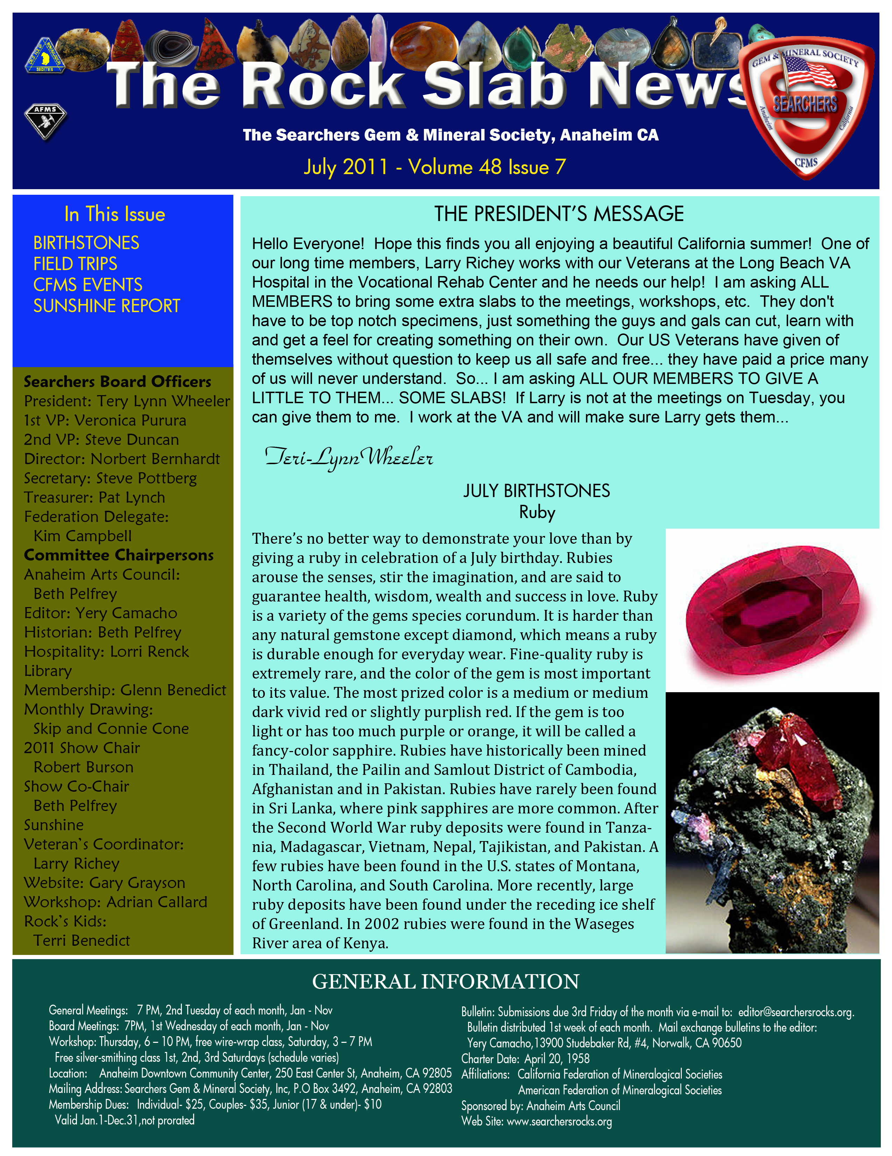

FIELD TRIPS

FIELD TRIPS 2010/ 2011
Date | Leader | Location & material | Status
Sept 25&26, 2010 | Robert Burson | Mule Canyon –agate and jasper, also possibly silver onyx | Done
Oct 9 &10, 2010 | Norbert Bernhardt | Lucerne Valley-orbicular rhyolite and ?? | Done
Nov  Dates TBD | Steve Duncan-Joint trip with the Indian Wells club | Sheep Springs and Rainbow Ledge-agates and famous Rainbow Ridge jasp-agate | Done
Dec 12, 2010 Sunday | Steve Duncan | Sierra Pelona claim for banded onyx. Due to the busy holiday season this will be a one day trip | Done
Jan 21,22&23, 2011 | Steve Duncan | Burro Creek AZ-agate, jasper, pastelite | Done
Feb 19&20, 2011 | Jimmy Peterson | Siam Siding-Chapenite  Cadiz-trilobite fossils | Cancelled
Mar 19&20, 2011 | Robert Burson &  Jay Valle | Chuckwalla Mts-agates (plume, moss, fortification and banded) and jaspers | Done
APR 9&10, 2011 | Jimmy Peterson | Siam Siding-Chapenite  Cadiz-trilobite fossils | Done
May 14& 15, 2011 | Jim McGeough | Buffington Pockets Nevada  (about an hour outside of Vegas)- Blue agate | Done
May 28, 2011 | CFMS Trip | Calico Mountains for sagenite  Details at CFMS website | Done
June 11, 2011 | CFMS Trip | Somis-fossil sand dollars, clams, and sca;llops  Details at CFMS website | Done
July 15-19, 2011 | Norbert Bernhardt | Crystal Ridge  Quartz crystals and Garnets | Planned
July, 2011 | CFMS Trip | Greenhorn Mt-rose quartz  Details should become available on the CFMS website | CFMS Trip
Sept 16,17&18, 2011 | CFMS Trip | Jade Cove-Jade and Serpentine  Details should become available at the CFMS website | CFMS Trip
Sept 10 & 11, 2011 | Steve Duncan | Sandy Wash for agate  Lucerne valley for orbicular rhyolite | Planned
Oct TBD | Jim McGeough | Goldfield Nevada  Agates and more  3 collecting days trip | Tentative
Nov, 2011  Dates TBD | Robert Burson | Baxter Wash?  Chuckwallas?  Wileys Well? | Tentative

For a more complete listing of shows go to website: www.cfmsinc.org
Also see www.motherlodemineralsociety.com/events.html.

Other websites of interest:

www.firemountaingems.com
www.southsunproducts.com www.route66goldminers.org
www.pioneergem.com www.auctionmasters.com

Club Meeting Activity Schedule 2011
Date | Presenter | Subject
Tuesday, July 12th | Lothar Vallot | “Simulates, Synthetics, and Treatments”
Tuesday, Aug 9th | NONE | Rock swap
Tuesday, Sep 13th | Joe Girtner | “Jewelry Processes – inlay, jewelry design, process, and sculpting”
Tuesday, Oct 11th | NONE | Silent Auction
Tuesday, Nov 8th | None | Officer election/pie night

Upcoming CFMS Gem Shows

July 9-10 - CULVER CITY, CA
Culver City Rock & Mineral Club
Veterians Memorial Auditorium
4117 Overland Ave (Overland & Culver)
Hours: Sat 10-6; Sun 10-5
Robert Thirlaway
Website: http://www.CulverCityRocks.org
August 5-7 - NIPOMO, CA
Orcutt Mineral Society
St. Joseph's Church Recreation Hall
298 S. Thompson Ave.
Hours: 10-5 daily
Gloria Dana (805)929-6429
Email: info@onsinc.org
Website: www.omsinc.org

August 6-7 - SAN FRANCISCO, CA
San Francisco Gem & Mineral Society
Golden Gate Club
136 Fisher Loop, The Presidio of San Francisco
Hours: Sat. 10-6; Sun. 10-5
Carleen Mont-Eton (415)564-4230
Email: publicity@show.sfgms.org
Website: www.sfgms.org
September 2-5 - FORT BRAGG, CA
Mendocino Coast Gem & Mineral Society
Town Hall
363 N. Main St, (corner of Main & Laurel)
Hours: Fri-Sun 10-6; Mon 10-4
Jerry Sommer (707) 917-1833
September 10-11 - DOWNEY, CA
Delvers Gem & Mineral Society
Woman's Club of Downey
9813 Paramount Blvd.
Hours: Sat 10-6; Sun 10-4
Guynell Miller (562) 633-0614
September 17-18 - STOCKTON, CA
Stockton Lapidary & Mineral Club
Scottish Rite Masonic Center
33 W. Alpine Avenue
Hours: 10-5 Daily
Jan Bradley or Dorothy Tonnacliff (209) 629-3837 / (209) 603-4539
Email: slmcshow@juno.com
Website: http://www.stocktonlapidary.com
September 24-25 - MONTEREY, CA
Carmel Valley Gem & Mineral Society
Monterey Fairgrounds
2004 Fairgrounds Road
Hours: Sat 10-6; Sun 10-5
Matt Biewer (831) 659-4156
Email: mattbiewer@aol.com
Website: http://www.cvgms.org
October 8-9 - TRONA, CA
Searles Lake Gem & Mineral Society
13337 Main Street
Hours: Sat; 7:30-5; Sun. 7:30-4
Jim &am; Bonnie Fairchild (760) 372-5356
Email: slgms@iwvisp.com
Website: www1.iwvisp.com/tronagemclub
October 15-16 - ANDERSON, CA
Shasta Gem & Mineral Society
Shasta Distrist Fairgrounds
Briggs Street
Hours: Sat. 9-5; Sun. 10-4
Steve Puderbaugh (530) 365-4000; Cell (530) 604-2951
Email: steve@applyaline.com
Website: www.www.shastagemandmineral.com
October 15-16 - PLACERVILLE, CA
El Dorado County Mineral & Gem Society
El Dorado County Fairgrounds
100 Placerville Drive
Hours: 10-5 daily
Karen Newlin, (530) 676-2472
Email: info@rockandgemshow.org
Show Website: www.rockandgemshow.org
October 15-16 - SANTA ROSA, CA
Santa Rosa Mineral & Gem Society
Veterans Memorial Auditorium
1351 Maple Ave
Hours: Sat. 10-6: Sun 10-5
Debbie Granat (707) 542-1651
Email: santarosarockshow@hotmail.com
Website: www.srmgs.org
October 15-16 - WHITTIER, CA
Whittier Gem & Mineral Society
Whittier Community Center
7630 Washington
Hours: 10-5 Daily
Marcia Goetz (626) 260-7239
Email: joemar1@verizon.net
November 5-6 - LANCASTER, CA
Palmdale Gem & Mineral Club
Antelope Valley Fairgrounds
2551 West Ave. H & Hwy 14
Hours: 9-5 daily
Cheri George, (562) 243-8470
Email: lizardwoman3@yahoo.com
Website: www.palmdalegemandmineral.com
November 5-6 - SAN DIEGO, CA
San Diego Mineral & Gem Society
Al Bahr Shrine Center
5440 Kearny Mesa Road
Hours: Sat. 9:30-5; Sun. 10-4
Bob Hancock, (619) 461-5783, (619) 889-6886 cell
Email: rhbobhancock@cs.com
Website: www.sdmg.org
November 19-20 - OXNARD, CA
Oxnard Gem & Mineral Society
Oxnard Performing Arts Center
800 Hobson Way
Hours: Sat. 9–5; Sun. 10–4
Norb Kinsler, (805) 644-6450
Email: show_info@oxnardgem.com
Website: http://www.oxnardgem.com

Owens Valley Field Trip
July 15-19, 2011
by Norbert Bernhardt

Our field trip will be to Owens Valley. This area is about 5 1/2 hours from Orange County.
The areas we will be going to have quartz crystals, smoky quartz, quartz crystals with hematite, pumpkin jasper and garnets. For those interested in fishing, bring your gear.

The campground we will be staying at is called Fort Independence (760-937-3150) and it will be on the left side of Hwy 395 after Independence, just past the Mt Whitney Fish hatchery turn-off. They charge $30.00 for full hook-up, down to $10.00 for no-hook-up. Restrooms and showers are on the premises. There are lots of large trees for shade in most areas.

For those that are looking for a motel:
Independence Courthouse Motel 800-801-0703
Independence Inn 530-945-0103
Mt Williamson Motel 866-428-4352

We will meet at the RV Park and leave for the collecting areas early at 8:00 am on Friday, 7am on Saturday and Sunday. We leave early because of the heat later in the day.
Bring backpacks, rock hammers, picks, gads, hiking shoes, and water. Be prepared for cool or warm weather. Most likely hot.
Plan for a pot-luck dinner on Saturday night.

Directions from Orange County: Take I-15 towards Victorville, 395 north past Lone Pine to Independence. The campsite is about 3 miles North of Independence off Hwy 395 just past Mt Whitney Fish hatchery turn-off.

Please contact me so that I know how many people will be going. Phone 714-904-2181 or e-mail at nbern@cox.net.

Field Trip Sept 10&11, 2011
Sandy Wash (in the South Cady’s) and Lucerne Valley
Agate, Jasper and Druzy in Sandy Wash, Orbicular Rhyolite in Lucerne

The September trip will be a bit different, in that we will actually be accessing two different locations that are not very close together. Saturday we will collect at Sandy Wash in the Cadys, one of our favorite places. One problem is that the BLM has closed the access road, so it will be about a 1 mile hike from where we park to the collecting. The collecting is agate and druzy in float, there is also agate to be dug, and if you are motivated there are very nice agate seams which you will need to hard rock mine (small sledge, chisels, gads, etc). We will spend all day here, so you will want to bring your lunch, as well as a lot of water. Saturday’s trip starts at 0830, we will leave from the campsite on Lavic Siding Rd.
Sat night we will camp at Lavic Siding, coincidentally there is good jasper collecting near the camp. I assume someone will be at the camp Friday for anyone who wants to come early. We will have our traditional Sat night potluck and bonfire.

Directions to the Lavic Camp:
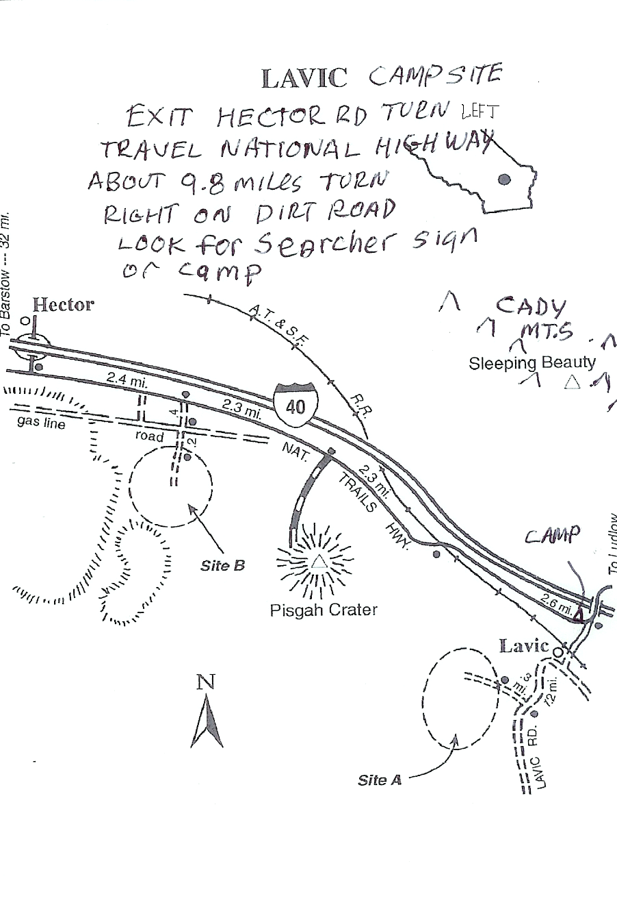
I15 north to Barstow, I40 east to hector road exit. Turn right at the bottom of the exit, and then left (east) on Nat’l Trails Hwy. Go about 9.8 miles to where Nat’l Trails Hwy makes a sharp left and crosses over the freeway. Do not cross over the freeway, instead turn right onto the dirt road Lavic Siding Rd. Camp is maybe a mile down this road, follow the Searcher signs. Sunday we will break camp early, and head to Lucerne. This is about a 1.5 hour drive. We will meet at the meeting place in Lucerne Valley (our normal campsite) at 1000 hrs. From there we will go to the nearby mine, and collect the orbicular rhyolite. Last trip we finally unlocked the secret of the orbicular rhyolite, and should be able to ensure everyone finds some. Digging bars and Geo picks (or the equivalent) will be helpful here, as some of the best material is collected by breaking apart rock faces. The rock faces are quite weathered, so they actually break quite easily into chunks. By 2 PM everyone should have all they need, and we will head for home.

Directions from Lavic Camp to the Lucerne Valley meeting point:
Return (I40W to I15S) to Barstow. Exit 183 to CA-247/Barstow Rd. Go south. Go 33.1 miles, at that point CA247 turns left, it is now CA247/Old Woman Spring Rd. Continue 5 miles on Old Woman Spring Rd to Camp Rock Road. Turn left on Camp Rock Rd and drive 3.9 miles, stay right at Sanitary Fill sign and drive 2.3 miles more. At this point the road turns to dirt. Drive 4.7 miles on the dirt and you will see a small hill with gray and black boulders. This will be our meeting spot, at 10:00 we leave for the collecting site, 3.7 miles from the meeting area.
The weather could be very hot, so be prepared with hats,, sunscreen, and lots of water. The campsite is a dry camp, with no facilities of any kind. There are supplies and gas available in Ludlow 7 miles east of Lavic Rd. There is also a funky motel there, there are many motels available back in Barstow if funky is not your style.

2011 National Veterans Arts Contest Winners
The Veterans Creative Arts Contest is an annual contest open to all patients from the Veterans Hospitals worldwide. Each hospital has its own contest and the 1st place winners from that contest , move up
to the Regional Level, than the 1st place winners move up to the National level. Their are thousands of entries from all over the world. Just to go to the National level is a huge achievement, but to win one of the top three places is an unbelievable achievement one can be quite proud of.

The National Veterans Creative Arts Festival (NVCAF) is the celebration and grand finale stage and art show which are the culmination of talent competitions in art, creative writing, dance ,drama and music for the veterans treated in the Department of Veterans affairs (VA) national health care system. Approximately 130 veterans will exhibit their artwork or perform in a gala show. All 1st place winners are selected to participate at the end of this year long contest. This years Gala Performance and Art Exhibit will be at Veterans Health Care System of the Oz arks in Fayetteville, Arkansas during the week of October 17-24, 2011.

VA medical facilities incorporate creative arts into their recreation therapy programs. This annual competition recognizes the progress and recovery made through that therapy, and raises the visibility of the creative achievements of our nation's veterans after disease, disability or life crisis.
This year we want to Congratulate the winners of this competition from Long Beach.

Category. Metal Work 2 d Place John Velazquez - Mariah project.
Military Combat Experience 3 rd Place Jesus Garza- Help me with my PTSD project.
All the projects this year really stepped up in Quality and it is too bad we are not allowed to send more than one per category. This is a tuff competition and all that entered should be VERY PROUD of your projects.

We would like to congratulate John and Jesse! These are the only two projects from any of the clinics at Long Beach this year! Great Job! I know Jessie is already planning his 2012 project.

For all of our Supporters:
VA medical Center (VRT) this has been a life changing experience. We want to Thank you for you support. Your support for our Long Beach program is the only reason this program is still available to
these veterans today. Without your support this program would not exist to day as it is the only one of the two Lapidary class in the VA System. With your support Long Beach has won nineteen (19) of the top three places and one (1) Special Recognition award at the nationals over the last twenty years
We thank you for all that you do to support this program at Long Beach.
We THANK YOU AND SALUTE YOU ALL!
Larry Richey

Messing with the El Paso MOUNtAIns
Posted by: "Onyx Collector" OnyxCollector@aol.com onyxcollector
Tue Jun 28, 2011 8:20 pm (PDT)
There's been a lot happening regarding access in the El Paso Mountains, and renewable energy in Indian Wells Valley. The latest BLM meeting explained that due to the WEMO related law suit in San Francisco by the Citizens for Biological Diversity, and resultant finding in their favor, the BLM must re-justify all access roads it has marked. My friend Last Chance Charlie remembers in 1987 or so when a low flying aircraft was seen a lot over Bickel Camp area, shortly after there had been a good rainfall which unfortunately covered many routes. The "data" from these flights is what's now being used by the BLM to mark routes that existed then, and the marking of those routes is now being done in the El Pasos. Routes seen today without markers are considered closed from the BLM's point of view. At the end of the route marking, sometime in 2014, the public is allowed a comment period to lobby for route designation according to the latest BLM meeting. The BLM has also
already culled duplicate routes, and dead end routes, so what we'll see marked in the next couple of weeks in the hills up there will not be all that existed even back then. Maps have not been distributed of the route system, so lots of questions are in the air regarding our access to rock hounding, 4wd routes, view spots, hunting areas, favorite camping areas, etc. Charlie will attempt to get some maps and distribute as soon as they're available. Charlei also believes the BLM will enact a fee based access sticker for the El Pasos some day soon. Thank you Charlie for this heads-up.

NOW THAT’S A DIFFERENT BUG
Scientists studying minerals in Mono Lake, California, have found that it has an unusual chemistry possibly due to its isolation from sources of freshwater over the last 50 years. High saline content - High alkaline content - High levels of arsenic. This is not so surprising, but, they also found in this harsh environment the first known microorganism on Earth able to thrive and reproduce using the toxic chemical arsenic. The microorganism substitutes arsenic for phosphorus in its cell components.
NASA’s Administrator for Science announced that “The definition of life has just expanded. We have to think more diversely and consider life as we do not know it” Prior to this, the six building blocks of life were carbon, hydrogen, nitrogen, oxygen, phosphorus and sulfur. Phosphorus is part of the backbone of DNA and RNA, the structures that carry genetic instruction for life and is considered an essential element for all living cells. It’s the main component of the energy carrying molecule in all cells and in the phospholipids that form all cell membranes.
Arsenic, which is chemically similar to phosphorus, is poisonous for most life on Earth because it disrupts metabolic pathways. It was known that some microbes could breathe arsenic, but this is the first instance of a life form building parts of itself out of arsenic. To quote Felisa Wolfe-Simon, a NASA Astrobiology Researcher, “If something here on Earth can do something so unexpected, what else can life do that we haven’t seen yet?”
Ref Geology.com, NASA publication in Brukner Rockette, via Calumet Gem 1/11, via PGGS E-Petrograph 6/11

Bench Tips
by Brad Smith
brad@greenheart.com
Santa Monica, CA USA
SOLDERING PRONGS
I often use prongs to hold an irregular cab or other object on rings and pendants. But they're a little tricky to solder. You have to find some way to hold them all upright while soldering, and what looks
like a strong joint sometimes turns out to be a fake. There's nothing worse than having a prong break off when you're setting the stone *#~*!
I solved both problems with one little trick. Locate and center punch the location for each prong. Then drill holes just a little smaller than your prong wire. Sand a small taper on the ends of your prong wires and insert them in the holes. The wires support themselves, soldering is easy, and the joint is stronger because of the increased soldering area.
TWISTING WIRE
Twisting wires together can be done with an old hand drill but goes much faster with a power tool. My preference is to use a screw gun, although a Dremel or Foredom should do well. Just make a little hook
out of coat hanger wire (or use a screw-in cup hook) and chuck it up in your screw gun. Fasten the ends of the wires in a vice and slip the other ends on your hook. Keep a little tension on the wires as you twist.
Note that a power drill is too fast a tool for this unless you have one with a variable speed control.
SMOOTHING EARWIRES
Any time you make your own earwires, the hardest part for me is to sand and polish the end that's inserted into the ear. Any sharp edge there is no fun. I've tried using sanding sticks, cup burs, and
silicone polishing wheels. I've tried buffing on a Zam wheel, and I've tried spinning the wire in the Foredom to polish the tip. While all of these techniques do the job, none are very easy or fast.
Then it occurred to me - I could melt the wire smooth. One quick touch in the flame of the propane/oxygen Little Torch does the trick - not enough to form a bead on the wire but just enough to round off the tip.

More BenchTips by Brad Smith are at
groups.yahoo.com/group/BenchTips/ or facebook.com/BenchTips

THE NEVADA MINERAL & BOOK COMPANY
http://minbooks.net/
342 S. Tustin Street • Orange, CA 92866
Ph. 714-633-1549

Rusty's Gold & Treasure Hunting Supply
Club members show your ID card and receive a 10% off purchases over $100
Authorized dealer for Garrett, Fisher, and Tesoro metal detectors
5642 E. La Palma Ave., #208, Anaheim, CA 92807 (corner of La Palma and Imperial Hwy.)
714 693-GOLD (4653). Store hours: Tu - Sat 10am - 6pm

